ABDOMINAL COMPARTMENT SYNDROME
Dr.T.Sadagopan .MD,DA. Professor of Anesthesiology. Coimbatore Medical College.
Introduction:-Abdominal Compartment Syndrome(ACS)is a grave abdominal condition identified by lethal raise of pressure in the closed abdominal cavity that results from various causes. First recognized in the year 1863 by Marey as a primary cause of respiratory difficulty in critically ill patient. The elevated Intra Abdominal Pressure (IAP) viciously damages the organs culminating in Multi Organ Dysfunction Syndrome (MODS). (SJTR&EM 2009).

Primary ACS
Causes of primary (ie, acute) abdominal compartment syndrome include the following:
- Penetrating trauma
- Intra peritoneal hemorrhage
- Pancreatitis ^{[2]}
- External compressing forces, such as debris from a motor vehicle collision or after a large structure explosion
- Pelvic fracture
- Rupture of abdominal aortic aneurysm ^{[1,2]}
- Perforated peptic ulcer
In one review and meta-analysis of studies of patients who developed ACS after repair of ruptured abdominal aortic aneurysms, mortality was found to be 47%. Treatment included open decompression in 86 patients; percutaneous drainage in 18 (catheter only in 5; combined with tissue plasminogen activator infusion in 13); and conservative measures in 5.^{[ref 123]}

Secondary ACS
Secondary abdominal compartment syndrome may occur in patients without an intra-abdominal injury, when fluid accumulates in volumes sufficient to cause IAH. Causes include the following:
- Large-volume resuscitation: The literature shows significantly increased risk with infusions greater than 3 L.
- Large areas of full-thickness burns : Hobson et al demonstrated abdominal compartment syndrome within 24 hours in burn patients who had received an average of 237 mL/kg over a 12-hour period. ^{[3,4]}
- Penetrating or blunt trauma without identifiable injury
- Postoperative
- Packing and primary fascial closure, which increases incidence
- Sepsis
A retrospective study reported on risk factors directly associated with mortality in patients with both intra-abdominal hypertension and ACS. Poly transfusion was a strong predictor of mortality, along with a reported history of diabetes and the total amount of blood products used.^{[1234]}
Secondary ACS in patients with lower extremity vascular injuries from penetrating injury or blunt trauma was associated with a 60% mortality in one study.
Chronic: -
Causes of chronic abdominal compartment syndrome include the following:
- Peritoneal dialysis
- Morbid obesity
- Cirrhosis
- Meigs syndrome
- Intra-abdominal mass 1
There is no age, sex and racial specificity in the incidence of the Abdominal Compartment Syndrome. The mortality ranges from 25 to 75 percent all over the world. The global reporting of the incidence exceeds that in the United States of America.
Pathophysiology
Organ dysfunction with abdominal compartment syndrome is a product of the effects of IAH on multiple organ systems. Abdominal compartment syndrome follows a destructive pathway similar to compartment syndrome of the extremity.
Problems begin at the organ level with direct compression; hollow systems such as the intestinal tract and portal-caval system collapse under high pressure. Immediate effects such as thrombosis or bowel wall edema are followed by translocation of bacterial products, leading to additional fluid accumulation, which further increases intra-abdominal pressure.
At the cellular level, oxygen delivery is impaired, leading to ischemia and anaerobic metabolism. Vasoactive substances such as histamine and serotonin increase endothelial permeability; further capillary leakage impairs red cell transport; and ischemia worsens.Simon et al demonstrated a significantly lowered threshold for injury from IAH in pigs after hemorrhage and fluid resuscitation.^{[1]} Oxygen delivery may play an important role.
Although the abdominal cavity (ie, the peritoneal and, to a lesser extent, retroperitoneal cavities) is much more distensible than an extremity, it reaches an endpoint at which the pressure rises dramatically. This is less apparent in chronic cases because the fascia and skin slowly stretch and thus tolerate greater fluid accumulation. As pressure rises, abdominal compartment syndrome impairs not only visceral organs but also the cardiovascular and the pulmonary systems; it may also cause a decrease in cerebral perfusion pressure. Therefore, abdominal compartment syndrome should be recognized as a possible cause of de compensation in any critically injured patient. The increased intra abdominal pressure resulting in hypoxia induces release of cytokines, formation of oxygen free radicals and decreased cellular production of Adenosine tri phosphate.
The following picture outlines the schematic representation of the multiple organs functional compromise due to the Abdominal Compression Syndrome.

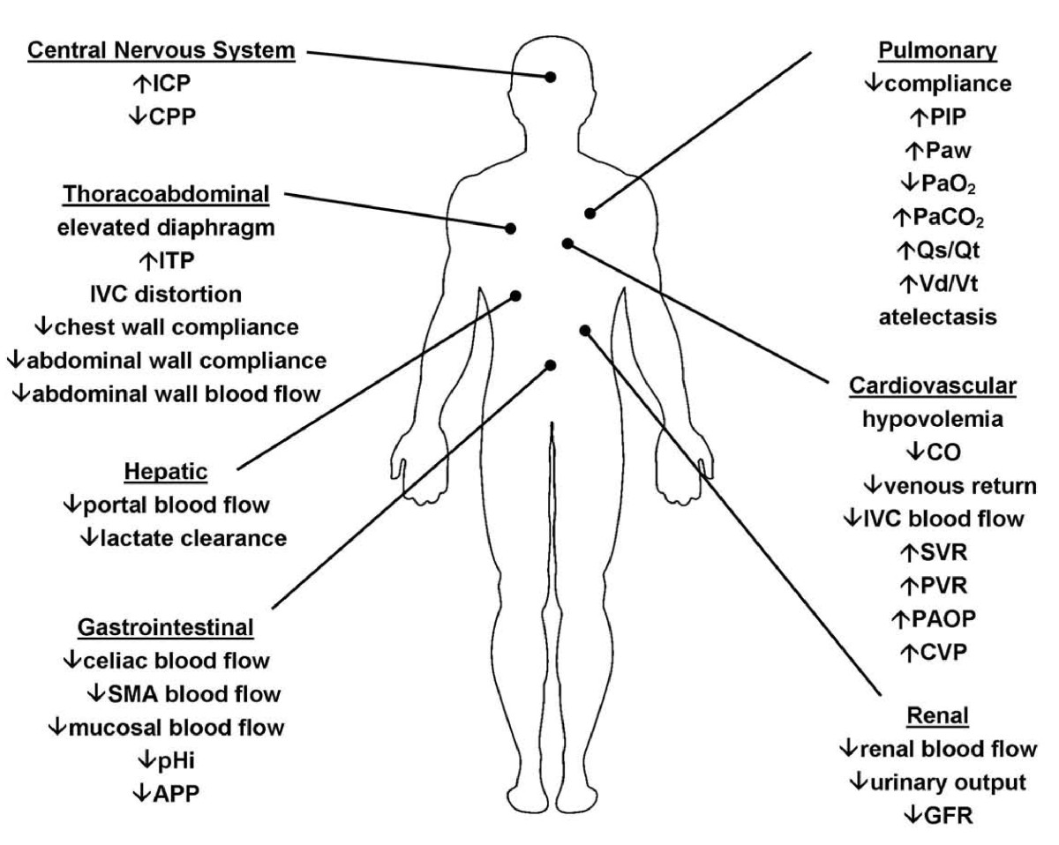 2

Grading:- In an excellent group of articles, Burch et al developed a grading system.^{[13]}Patients with higher-grade abdominal compartment syndrome have end-organ damage, which is evidenced by splenic hypercarbia and
elevated lactate levels, even if they appear clinically stable. The following grading system has become accepted if IAH is present:
- Grade I: 10-15 cm H ₂ O
- Grade II: 15-25 cm H ₂ O
- Grade III: 25-35 cm H ₂ O
- Grade IV, greater than 35 cm H ₂ O
End-organ damage has been observed with IAP as low as 10 cm H₂ O, and multiple studies have found damage at values ranging from 20-40 cm H₂ O. Disparity exists because abdominal compartment syndrome never occurs as an isolated event.
Cheatham et al found abdominal perfusion pressure (APP) to be a much better predictor of end-organ injury than lactate, pH, urine output, or base deficit.^{[14]} The APP is equal to the mean arterial pressure minus the IAP.

IAP measurement :-The sensitivity of both clinical judgement and physical examination have been demonstrated to be very poor in predicting a patient's IAP. Early, serial IAP measurements are therefore essential to both diagnosing the presence of IAH as well as guiding resuscitative therapy. While a variety of methods for IAP measurement have been described, intravesicular or "bladder" pressure has achieved the most widespread adoption worldwide due to its simplicity, minimal cost, and low risk of complications. Several key points must be considered to ensure accurate and reproducible IAP measurements. Early IAH studies utilized water manometers to determine IAP with results reported in cm H₂O while subsequent studies using electronic pressure transducers reported IAP in mmHg (1 mmHg = 1.36 cm H₂O). This led to confusion and difficulty in comparing studies. A point of further confusion has been the appropriate zero reference point for the abdomen. Changes in body position (i.e., supine, prone, head of bed elevated) can have a significant impact upon the measured IAP. While head of bed elevation is now commonly performed to reduce the incidence of ventilator-associated pneumonia, the clinical studies that determined the threshold IAP values that lead to organ dysfunction were determined in the supine position. Further, the presence of both abdominal and bladder detrusor muscle contractions have been demonstrated to impact the accuracy of IAP measurements. Perhaps the greatest point of contention has been the proper priming-volume to be instilled into the bladder to ensure a conductive fluid column between bladder wall and transducer. Large instillation volumes, as commonly utilized in years past, have been demonstrated to result in artificial increases in IAP that could lead to inappropriate therapy. In an attempt to address these issues and ensure both the accuracy and reproducibility of IAP measurements, the WSACS has recommended that IAP be expressed in mmHg and measured at end-expiration in the complete supine position after ensuring that abdominal muscle contractions are absent and with the transducer zeroed at the level of the mid-axillary line. Further, IAP should be measured via the bladder with a maximal instillation volume of 25 mL of sterile saline.
3

Normal and Pathologic IAP values
Normal IAP ranges from sub-atmospheric to zero mmHg. In the typical intensive care unit patient, however, IAP is commonly elevated to a range of 5–7 mmHg while patients with recent abdominal surgery, sepsis, organ failure, or need for volume resuscitation may demonstrate IAPs of 10–20 mmHg. Prolonged elevation in IAP to such levels can result in organ dysfunction and failure while pressures above 25 mmHg are associated with significant potential mortality.
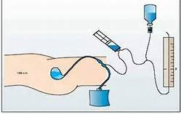 The diagram indicates the surrogatory pressure measurement of the bladder. Physiologic consequences of persistent elevated intra-abdominal pressure:

DECREASED

- Cardiac output
- Central venous return
- Visceral blood flow
- Renal blood flow
- Glomerular filtration

INCREASED

- Cardiac rate
- Pulmonary capillary wedge pressure
- Peak inspiratory pressure
- Central venous pressure
- Intra pleural pressure
- Systemic vascular resistance
4
Clinical presentation :-
The commonest finding is increased abdominal girth that is beyond normal for the patient. If this change is acute, the abdomen is tense and tender. Although this may be difficult to recognize in patients with morbid obesity, other patients often have an abdomen clearly out of proportion to their body habitus. This may be easier to visualize with the patient standing or sitting upright. In addition to distended abdomen, other secondary effects of abdominal compartment syndrome are as follows: Wheezes, rales, increased respiratory rate Cyanosis Wan appearance
Signs and symptoms can include the following:
- Increase in abdominal girth
- Difficulty breathing
- Decreased urine output
- Syncope
- Malena
- Nonsteroidal anti-inflammatory drug (NSAID) use
- Alcohol abuse
- Nausea and vomiting
- History of pancreatitis
Abdominal compartment syndrome may be obscured in patients with critical injuries. Failure to consider abdominal compartment syndrome prevents diagnosis and treatment. Many disease processes can contribute to abdominal compartment syndrome. Consider IAH and document intra-abdominal pressures in any of the following patients:
- Intubated patients who have high peak and plateau pressures and are difficult to ventilate
- Patients who have GI bleeding or pancreatitis and are not responding to intravenous (IV) fluids, blood products, and pressors.
- Patients who have severe burns or sepsis with decreasing urine output and are not responding to IV fluids and pressors
- Any patient with contradictory Swann-Ganz readings.

Differential Diagnosis :-
- Abdominal Trauma, Blunt
- Appendicitis, Acute
- Cholangitis
- Congestive Heart Failure and Pulmonary Edema
- Dissection, Aortic
- Diverticular Disease
- Foreign Bodies, Gastrointestinal
- Mesenteric Ischemia
- Bacteremia and Sepsis
- Urinary Obstruction

Clinical approach and investigations:-Laboratory studies and abdominal computed tomography scan are essential to identify ACS.. Measure intra-abdominal pressure (IAP) if abdominal compartment syndrome is suspected. IAP can be easily monitored by measuring bladder pressure.

5

The following lab studies may be indicated:
- Comprehensive metabolic panel (CMP)
- Complete blood cell count (CBC)
- Amylase and lipase assessment
- Prothrombin time (PT), activated partial thromboplastin time (aPTT) if the patient is heparinized
- Cardiac marker assays
- Urinalysis and urine drug screen
- Measurement of serum lactate levels (at many institutions, the sample must be kept on ice)
Arterial Blood Gas Analysis.This is a quick way to measure the pH, lactate, and base deficit.

Abdominal CT scanning can reveal many subtle findings.
- Round-belly sign: Abdominal distension with an increased ratio of antero posterior-to-transverse abdominal diameter (ratio >0.80)
- Collapse of the vena cava
- Bowel wall thickening with enhancement
- Bilateral inguinal herniation

Plain abdominal radiographic studies are often useless in identifying abdominal compartment syndrome, although they may show evidence of free air or bowel obstruction. Abdominal ultrasonography may reveal an aortic aneurysm, particularly with large aneurysms, but bowel gas or obesity makes performing the study difficult.

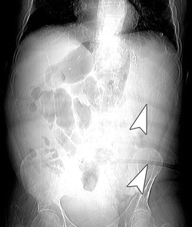

The radiological finding of herniation into the mediastinum. (Ref. 11)

6

Pulmonary :-
Increased Intra abdominal pressure causes:
Elevation of diaphragm, reduced lung volumes & alveolar inflation, stiffness of thoracic cage and increase in interstitial fluid level.
Impact:-
-- Raise in intra thoracic pressure( which further reduces the venous return to heart, exacerbating the cardiac complications)
-- Increase in peak pressures and reduction in tidal volumes.
-- Barotrauma- atelectasis, hypoxia, hypercarbia
-- ARDS
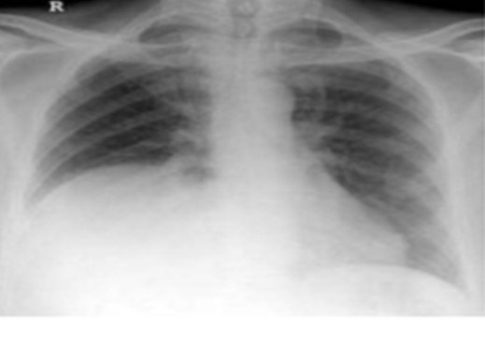

7
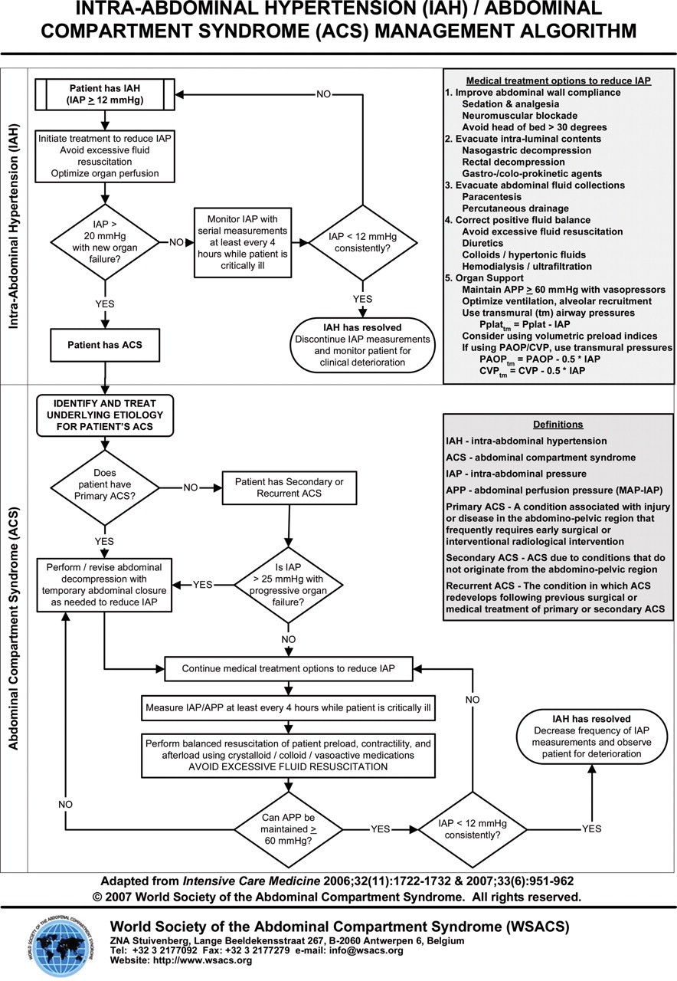8

ICU/ED Management of Abdominal compartment Syndrome :-
Medical management:-
WSACS suggests the nonsurgical management of ACS patient with regular monitoring of Intra Abdominal Pressure and a proactive approach.
Procedures Lowering of IAP :-
Supine positioning, Nasogastric tube insertion to decompress abdomen.
Enemas, flatus tubes, and prokinetic agents.
Endoscopic percutaneous decompression of GIT by draining fluids and gases.
Coughing , straining and ventilator asynchrony may be reduced by sedation. Cardiac output need to be monitored.
Organs support:-
Optimization of cardiac output.
Optimal fluid resuscitation to prevent hypovolemia and restoring normovlemia. Cardiac stroke volume variations to be considered for volume replacement.
To maintain the optimal IAP of 60 mmhg inotropic or vasopressors may be used.
Renal replacement therapy for renal compromised patients.
Lung protective strategies may be adopted with respect to ventilation.
Enteral and parenteral feeds to help maintain the gut integrity.
Thrombo prophylactic measures to prevent DVT in immobilized patients with venous stasis.
Surgical Management :-
Surgical decompression (open abdomen) reduce the IAP . Incision of the linea alba with intact peritoneum. Bagota” bag closure of the abdomen are a few emergency procedures.
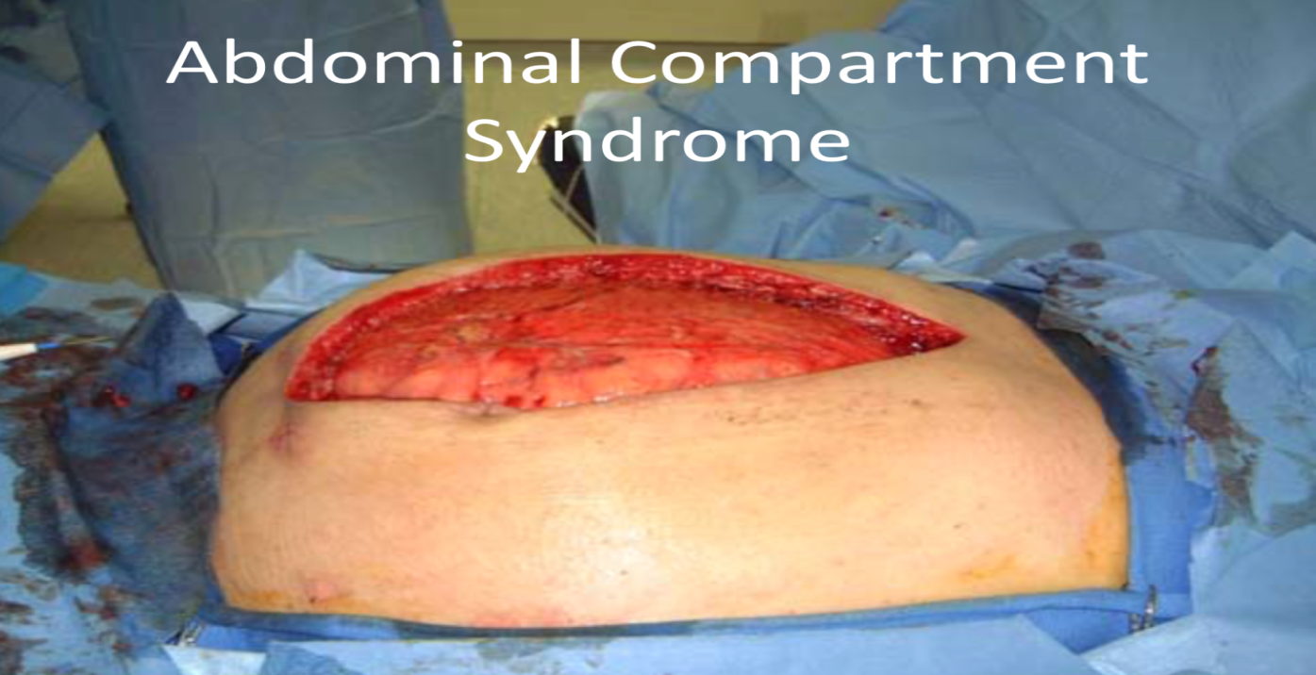
9

The patients are critically ill and anaesthetic management needs careful considerations. There are four key concerns specifically related to patients with abdominal compartment syndrome.
Pharmacokinetics/dynamics
Patients with abdominal compartment syndrome may be more sensitive to the cardiac depressant effects of induction agents due to liver dysfunction, altered drug handling, altered volume of distribution, and hypovolaemia. A reduced dose of drug and careful induction with invasive monitoring is required.
Sudden decrease in intra-thoracic pressure
As the abdomen is opened, the intra-abdominal pressure rapidly equilibrates with atmospheric pressure. There is a consequent decrease in the intra-thoracic pressure. A dramatic increase in respiratory compliance may occur, with the potential of ‘over ventilation’ and damage to lung parenchyma due to barotrauma and volutrauma. Therefore, close attention to airway pressures/tidal volumes should be paid.
Sudden decrease in systemic vascular resistance
On opening the abdomen, afterload will fall as may cardiac output and arterial pressure. This may be profound, resulting in sudden cardiac arrest. Further fluid loading and/or vasopressors may be required, and resuscitation drugs and equipment should be close at hand.
Reperfusion injury
Finally, on opening the abdomen, previously ischaemic areas of bowel and viscera may once again be perfused, leading to a systemic reperfusion insult with potential of myocardial depression, arrhythmias, and, on occasion, cardiac arrest.
With all of these patients, senior anaesthetic staff should be available and extreme care and vigilance should be taken at induction of anaesthesia and on opening of the abdomen. Resuscitation drugs and equipment should be immediately available whenever sudden cardiac arrest results.

Anaesthesia for Abdominal Compartment Syndome :-
Both General Anaesthesia and Regional Anaesthesia have selective restrictions in the Abdominal Compartment Syndrome. The patients fall in to the ASA Grade IV or V criteria. Precipitation of Hypotension , Renal failure, cardiac arrest and cerebral edema is high and refractory to emergency resuscitation.
Premedication with narcotics as well as induction with barbiturate,propofol precipitate severe hypotension and cardiac arrest. Ketamine induction is controversial although it maintains the average blood pressure, the increase in intracranial pressure secondary Abdominal Compression Syndrome may raise further . Valid supportive documentary evidences are not available.
In the presence of renal damage depolarizing muscle relaxants and non depolarizing agents that depend on the renal clearance are harmful in the maintenance of anaesthesia. Most of the evidences support the use of atracurium with enhanced safety with cis atracurium. 10

Regional Anaesthesia :
There are no definitive supportive evidences to advocate any particular neuraxial blockade specific for the patients with Abdominal Compartment Syndrome. A partial fall in the systemic vascular pressure may significantly abolish the protective reflexes maintaining the perfusions in the kidney, liver and the brain. In our experience in the Gastroenterology clinics, a selective Epidural blockade of less than 5 or 6 segments reduces the discomfort to the patient who are conscious with ventilator support.
Conclusion
The abdominal compartment syndrome is defined as intra abdominal hypertension associated with organ dysfunction. Adverse physiology has been demonstrated in pulmonary, cardiovascular, renal, musculoskeletal and central nervous system function. Identification of patients at risk, early recognition, and appropriately staged and timed intervention is key to effective management of this condition. Under most circumstances following abdominal decompression, immediate primary fascial closure is obviated. Alternative means for coverage of the abdominal contents include skin closure with towel clips or suture, abdominal wall advancement flaps, plastic or silicone coverage, and mesh interposition grafts. The perioperative anaesthetic management is a great challange and mortality rises up to 75% in moribund patients.

References:-
1.Blunt Abdominal Trauma: Author: Eric L Legome, MD; Chief Editor: John Geibel, MD, DSc, MSc, MA
2.Penetrating Abdominal Trauma: Author: Patrick Offner, MD, MPH; Chief Editor: John Geibel, MD, DSc, MSc, MA
a.Simon RJ, Friedlander MH, Ivatury RR, et al. Hemorrhage lowers the threshold for intra-abdominal hypertension-induced pulmonary dysfunction. J Trauma. 1997 Mar. 42(3):398-403; discussion 404-5. [Medline].
b. De Waele JJ, Ejike JC, Leppäniemi A, De Keulenaer BL, De Laet I, Kirkpatrick AW, et al. Intra-abdominal hypertension and abdominal compartment syndrome in pancreatitis, paediatrics, and trauma. Anaesthesiol Intensive Ther. 2015. 47 (3):219-27. [Medline].
c. Rubenstein C, Bietz G, Davenport DL, Winkler M, Endean ED. Abdominal compartment syndrome associated with endovascular and open repair of ruptured abdominal aortic aneurysms. J Vasc Surg. 2015 Mar. 61 (3):648-54. [Medline].
d. Karkos CD, Menexes GC, Patelis N, Kalogirou TE, Giagtzidis IT, Harkin DW. A systematic review and meta-analysis of abdominal compartment syndrome after endovascular repair of ruptured abdominal aortic aneurysms. J Vasc Surg. 2014 Mar. 59(3):829-42. [Medline].
e. Malbrain ML, De Keulenaer BL, Oda J, De Laet I, De Waele JJ, Roberts DJ, et al. Intra-abdominal hypertension and abdominal compartment syndrome in burns, obesity, pregnancy, and general medicine. Anaesthesiol Intensive Ther. 2015. 47 (3):228-40. [Medline].
f. Hobson KG, Young KM, Ciraulo A. Release of abdominal compartment syndrome improves survival in patients with burn injury. J Trauma. 2002 Dec. 53(6):1129-33; discussion 1133-4. [Medline].
g. Harrell BR, Melander S. Identifying the association among risk factors and mortality in trauma patients with intra-abdominal hypertension and abdominal compartment syndrome. J Trauma Nurs. 2012 Jul-Sep.
3.Blunt Abdominal Trauma in Adults By: Sheri A. Knepel, MD, Nicholas E. Kman, MD, Kevin O'Rourke, MD, and Hannah Hays, MDAugust 1, 2010 .
4.Abdominal Compartment Syndrome ;Author: Richard Paula, MD; Chief Editor: Trevor John Mills, MD, MPH .

5 .De Waele JJ, Hoste EAJ, Malbrain M -Decompressive laparotomy for abdominal compartment syndrome—a critical analysis. Crit Care 2006;10:R51.CrossRefMedlineGoogle Scholar

6.World society of abdominal compartment syndrome. 2004. Available from http://www.wsacs.org/ (accessed 7 January 2011) Cheatham ML, White MW, Sagraves SG, Johnson JL, Block EF
7.. Abdominal perfusion pressure: a superior parameter in the assessment of intra-abdominal hypertension. J Trauma 2000;49:621-6.
CrossRefMedlineWeb of ScienceGoogle Scholar
8.The Author [2012]. Published by Oxford University Press on behalf of the British Journal of Anaesthesia.
9.Continuing Education in Anaesthesia, Critical Care & Pain. the British Journal of Anaesthesia and The Royal College of Anaesthetists in the UK.
10.Contin Educ Anaesth Crit Care Pain (2012) doi: 10.1093/bjaceaccp/mks006 published online: March 8, 2012
11.American Journal of Roentgenology. 2007;189: 1037-1043. 10.2214/AJR.07.2092
: http://www.ajronline.org/doi/full/10.2214/AJR.07.2092#_i56
12. Ivatury RR, Diebel L, Porter JM, Simon RJ. Intra-abdominal hypertension and the abdominal compartment syndrome. Surg Clin North Am 1997; 77:783 –800 [CrossRef] [Medline]
13.Miller RD, Eriksson LI, Fleisher L, Wiener-Kronish JP, Young WL. Miller’s Anesthesia, 7th ed. Philadelphia, PA: Churchill Livingstone; 2009: 2253, 2302, and 2528.
14.Korean Journal of Anesthesiology 52(1):111 · January 2007 with 2 Reads DOI10.4097/kjae .2007.52.1.111.

